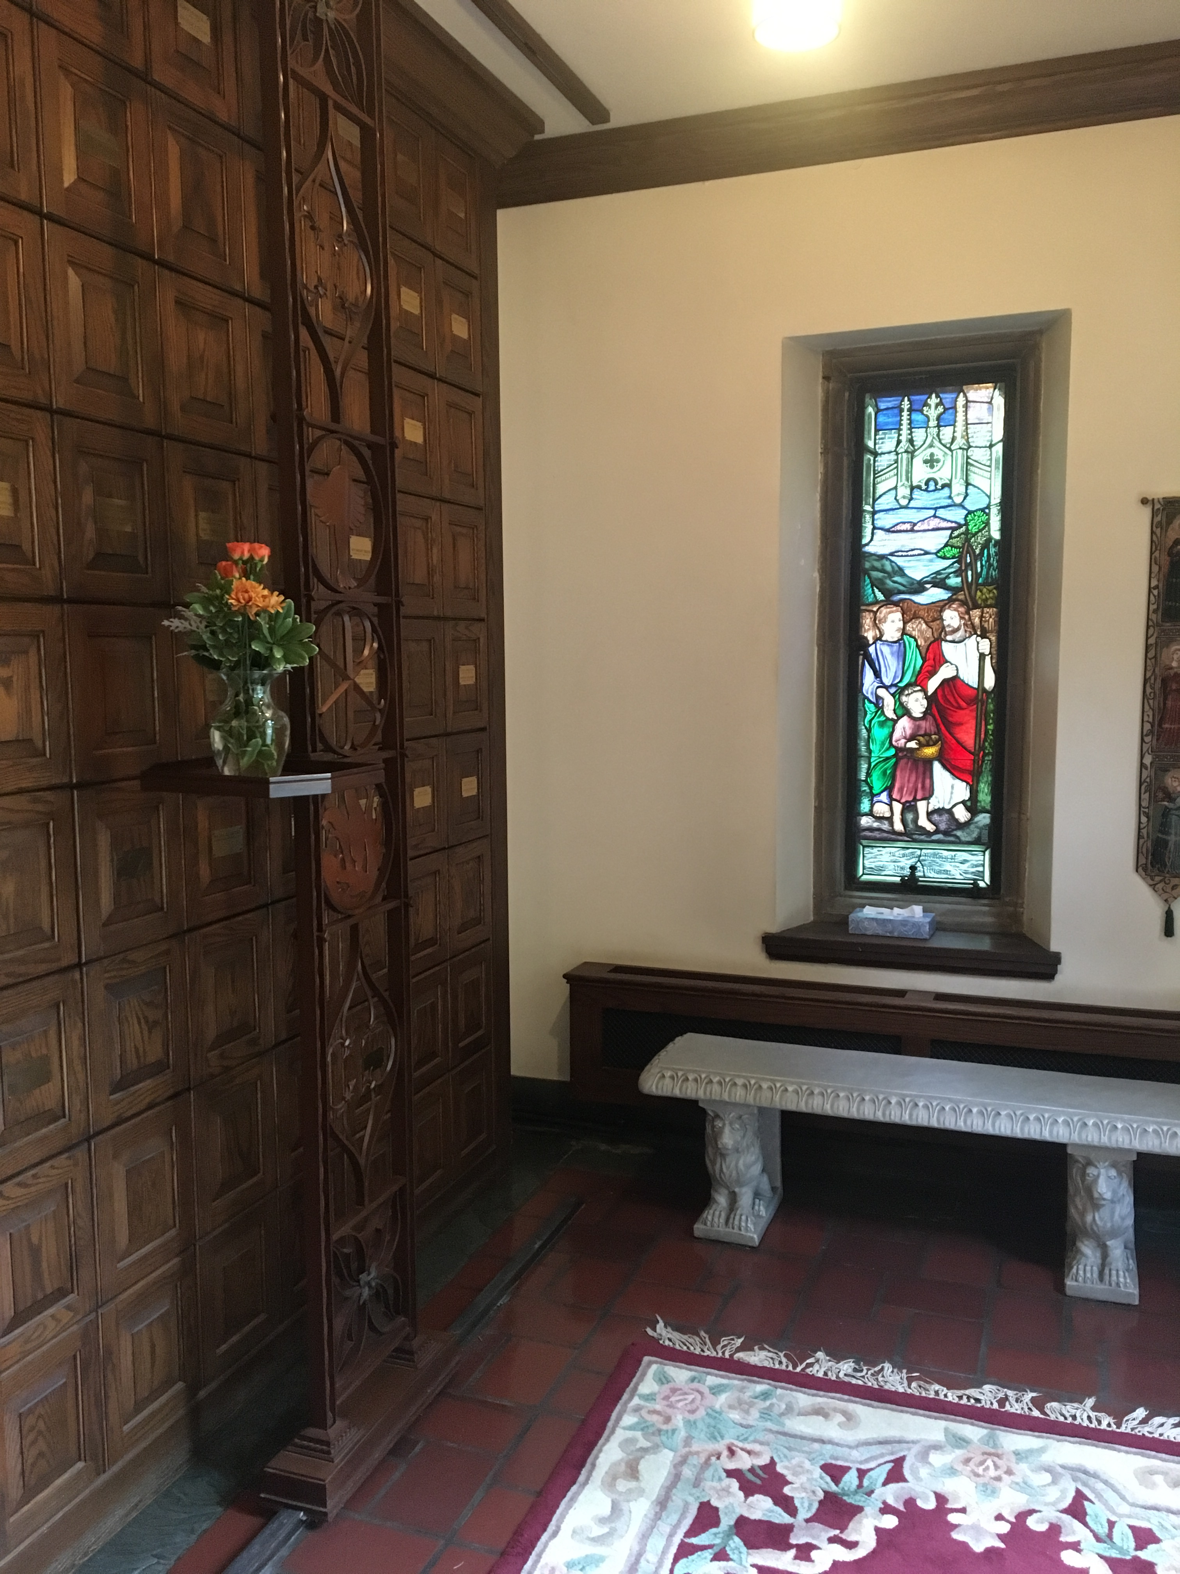  Columbarium Area  Right of church to remove cremated remains  The Church has the right to remove the cremated remains of the deceased and place such remains in any other appropriate location upon the relocation of the Columbarium for any reason.  Records and Accounts  The church shall maintain a record of each inurnment in the Columbarium and placement of a plaque. The name of the deceased in each inurnment, the deceased dates of birth and death and the deceased’s next of kin shall be included. The church shall also maintain a list of all eligible persons receiving niches, together with the names of the next of kin. | perpetual care  University Circle United Methodist Church is committed to the perpetual care of the ashes of those placed in the Columbarium. Although we do not foresee moving from our present location, if such a move occurs, the church Trustees are committed to moving the Columbarium to a place of dignity.  Contact Us  Phone: 1.216.421.1200  Website: www.churchinthecircle.com  University Circle United Methodist Church  1919 E. 107th Street Cleveland, Oh. 44106 | University Circle United Methodist Church  - The Jesse R. Hart, Jr. Columbarium
y:\columbarium\\columbarium brochuare2018(Final).docx
University Circle United Methodist Church  The Jesse R. Hart, Jr. Columbarium is named for one who was a loyal and faithful member of Epworth- Euclid Church for 64 years. Upon his death in 1998, his wife, Dorothy, requested that a portion of his memorial to the church be used to create the columbarium.  An elegant carved walnut face was selected by design firm John W. Winterich and Associates to display the columbarium’s 81 niches. Each niche has the capacity for a single urn, a double urn or two single urns. Cremated remains can be placed in the member’s niche after appropriate committal services for the deceased.  Why a columbarium?  Churchyard cemeteries have been a tradition in rural America. Because of limited space for full burials, many of today’s large urban churches have reclaimed this role by building columbaria where cremated remains of members and loved ones may be placed.  These consecrated environments provide space for individuals to meditate, reflect, remember, and celebrate the lives of those whose ashes are there. The practice of burial at the church completes the church’s ministry in life cycle, from birth to death, and provides a final resting place for persons who have been significantly bound to the church in life. The name Columbarium is derived from the Latin | word Columba or “dovecote,” the dove being the symbol of God’s spirit and peace  Eligibility  The Columbarium shall be reserved for use by (a) members and former members of the Congregation, (b) spouses of members and former members, (c) children or stepchildren of members and former members, (d) parents or stepparents of members of former members and (e) current or former pastors of the church, their spouses, children and stepchildren.  Reservation of Niches  Members of University Circle United Methodist Church may contract for a niche in the columbarium as interment for cremated remains for either themselves or certain close relatives. Each niche is licensed by a written agreement through the church office, at a cost of $1,000.  Memorial Garden  Human ashes are often called cremains. In the Memorial Garden, cremains are deposited directly into the topsoil during a special committal service. The actual location of an individual burial site is not marked — underscoring our commonality as baptized people who are united in Christ. Upon burial, the cremains become an integrated part of the garden topsoil, reminding us of what the scriptures tell us: “We come from dust, and we return to God through the dust of the soil.” | Burial in common soil is a holy act, a reverence-filled gesture of entrusting the cremains of saints to the everlasting arms of the Lord. Each internment space is licensed by a written agreement through the church office, at a cost of $1,000. Each internment space accommodates two cremains.  Cremation Costs  The cost of cremation is not covered by any fee or fees paid to the Church, and the Church will not offer any cremation services.  urns  University Circle United Methodist Church does not supply Urns. Ashes shall be in a durable container that is sealable; i.e., hardwood, bronze, stainless steel, or ceramic. The church reserves the right to reject any urn not acceptable.  PLAQUES  A nameplate is included for the front of the niche. Plaques affixed to niches will be of the uniform size, type and composition prescribed by the Church and will be obtained by the Church at no additional cost to the family.

